12/22/2014

# Instructions for using WinAutomation for EFiling Warrants

These instructions cover EFiling Petition for Warrant of Restitution to District Court of Prince George’s County, once the form has been signed by the plaintiff attorney (e.g. Kevin McParland).

## Preparation

Empty out the folders associated with efiling Warrants, highlighed in this screen shot. That is f:\cathy efile 2\Step W1…, Step W2…, and Step W3…

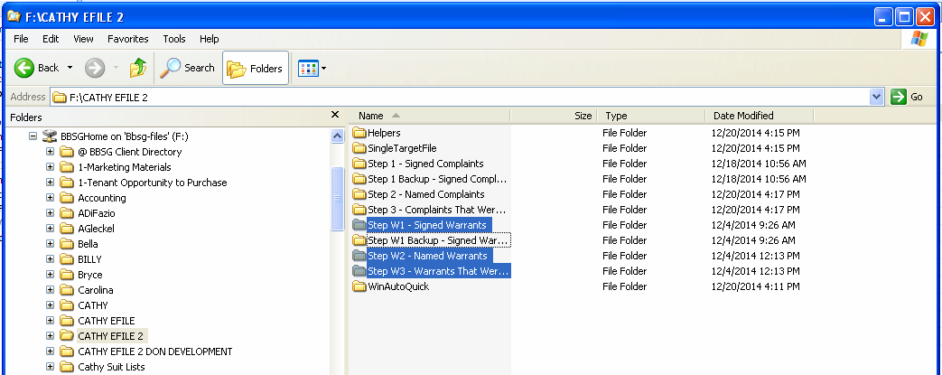

Scan each signed petition into a convenient directory, e.g. Z:\cathy. Go to that directory in Windows Explorer, and be click the icon next to “Folder” and select “Details”, so the date of each file is displayed. Highlight the relevant files with the mouse and shift key (based on the Date Modified), and copy to the W1 = Signed Warrants folder. (ctrl-C and Ctrl-V to paste)

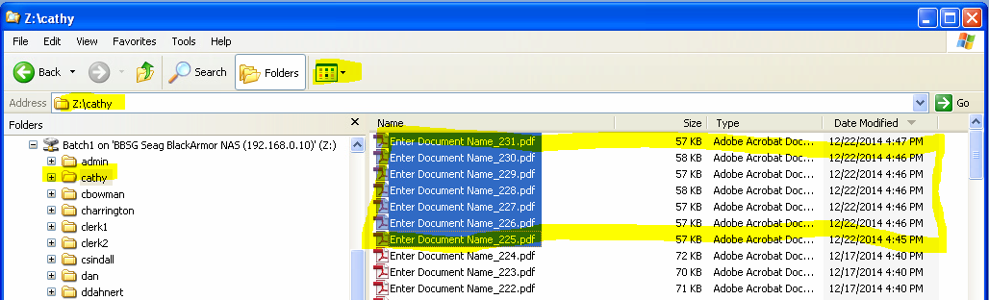

The result is shown below. Note the number of files (in this case there are 7)

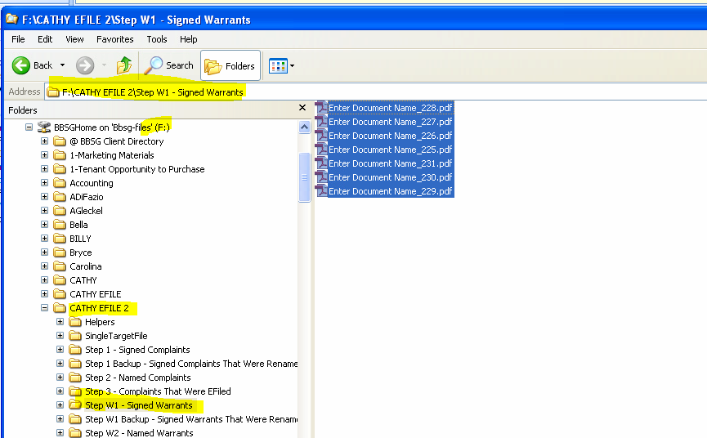

In the LTPROD Access application, Calculate Absolutes for the correct Property, Click Invoices, highlight the invoice associated with the Warrants. This may be several invoices back. Determine the correct warrant by Clicking Warrants, and seeing if there are the correct number of warrants (in the example, there are 7). When the correct invoice is highlighted, click EFWarr.

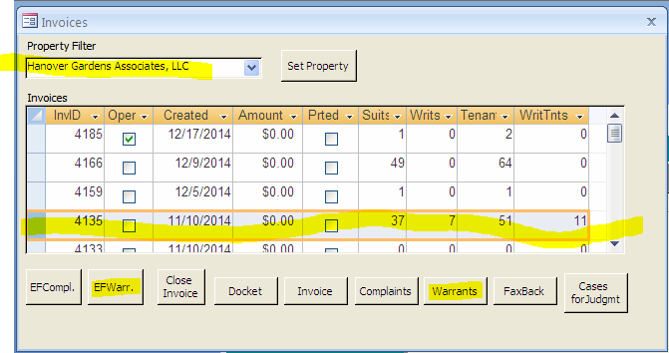

Accept the default “CSV” file name.

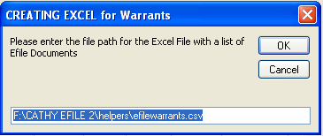

Enter the complex name, properly capitalized.

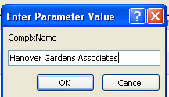

There should be the correct number of records in the generated cvs file. You can see there are 7 in this example. You can check later. However, if the Excel file is empty right here, you picked the wrong invoice.

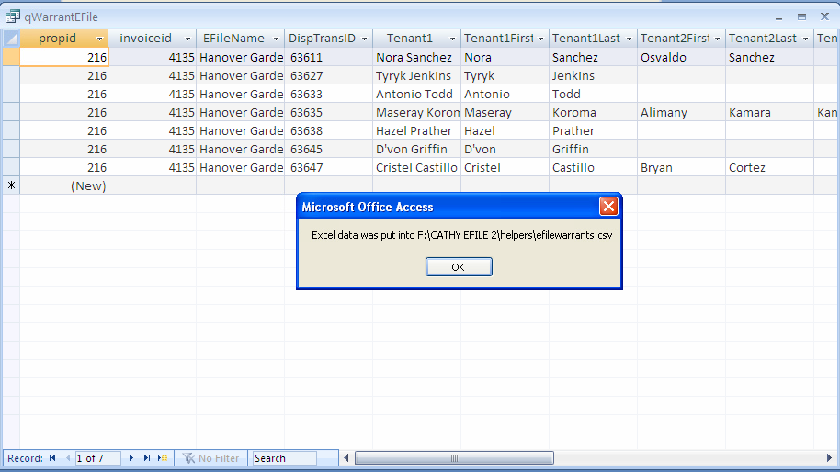

Close the Access application; you don’t need it.

In Windows explorer, find the .csv file just created. Be sure you have the right file, based on date. TIGHT click, and select Open.

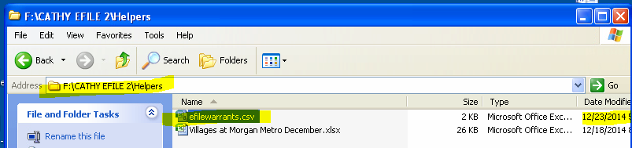

This brings up the file in Excel. Be sure you have the correct number of records. Then “Save As” an xlsx file, and give it the right name, based on property and date.

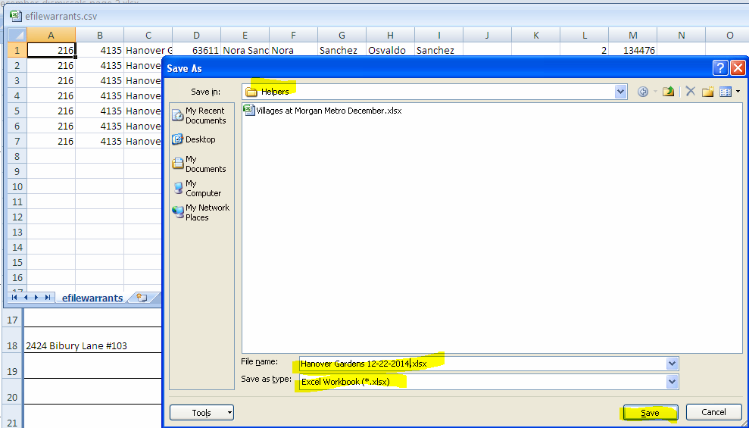

## Preparation is Finished, Rename the files

On the Desktop, double-click Shortcut to WinAutoQuick.



Right-click the W1 step, and select Open.

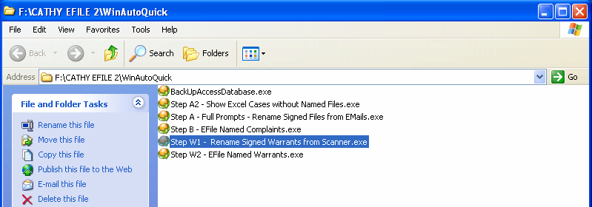

Close the WinAutoQuick Explorer Window, and click OK on the Message Box below.

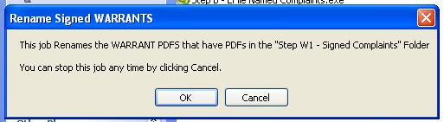

Enter your name (you must be registered with the system), so that the following file locations are correct.

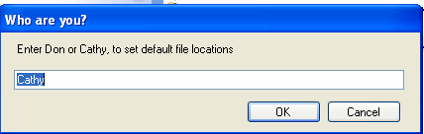

Say OK to 3 file locations, then pick the Helper File

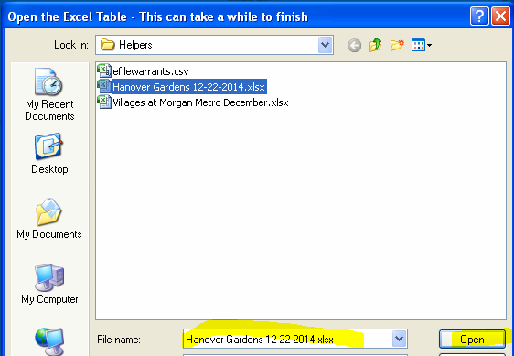

This will bring up each case mentioned in the .xlsx file that came from LTPROD. Type in the case number from the document, and click OK. If you type the number incorrectly, you will get a notice.

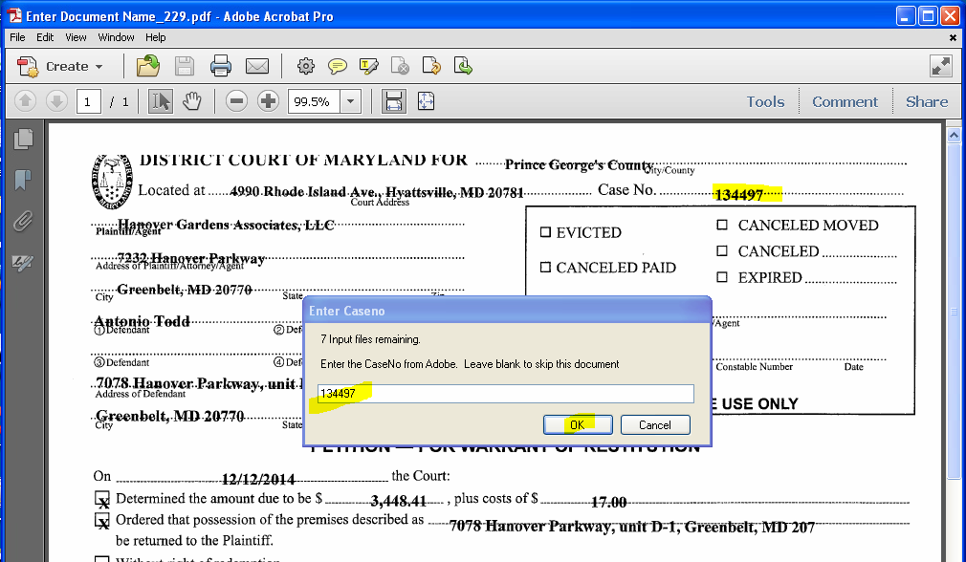

If you type the number correctly, you get a Match! Notice. You can verify that the names are correct, and click Yes. If you see a problem, you can click No, and fix things later.

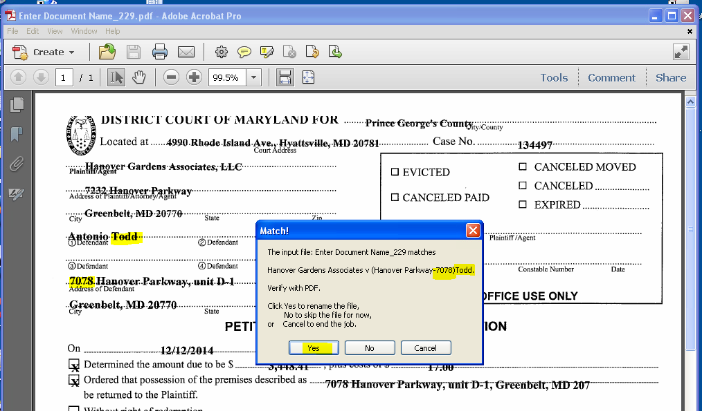

You then see a notice to CLOSE ADOBE! Close the Adobe Acrobat Pro window by clicking the X at the top right, THEN click OK.

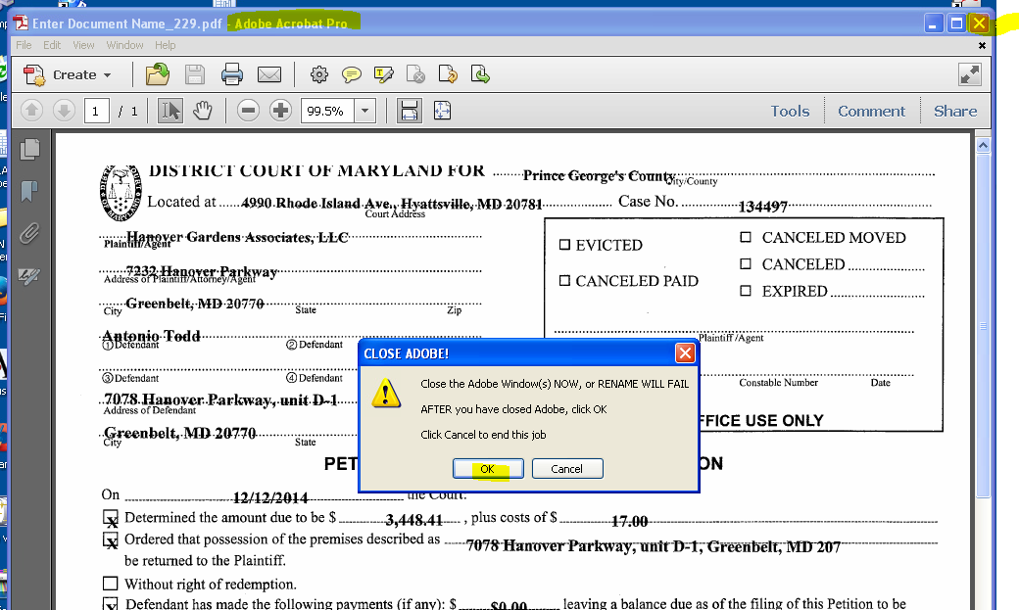

IF you fail to close the window, you get an error: Cannot rename file, and you will have to start again!

If all is OK, you are presented with the next document. The next screenshot shows how my minimizing windows you don’t need, and dragging the Adobe window down and left, you can make it easier to move the mouse from place to place. You want to minimize the distance from OK to the Close “X”, while still being able to see the Case No.

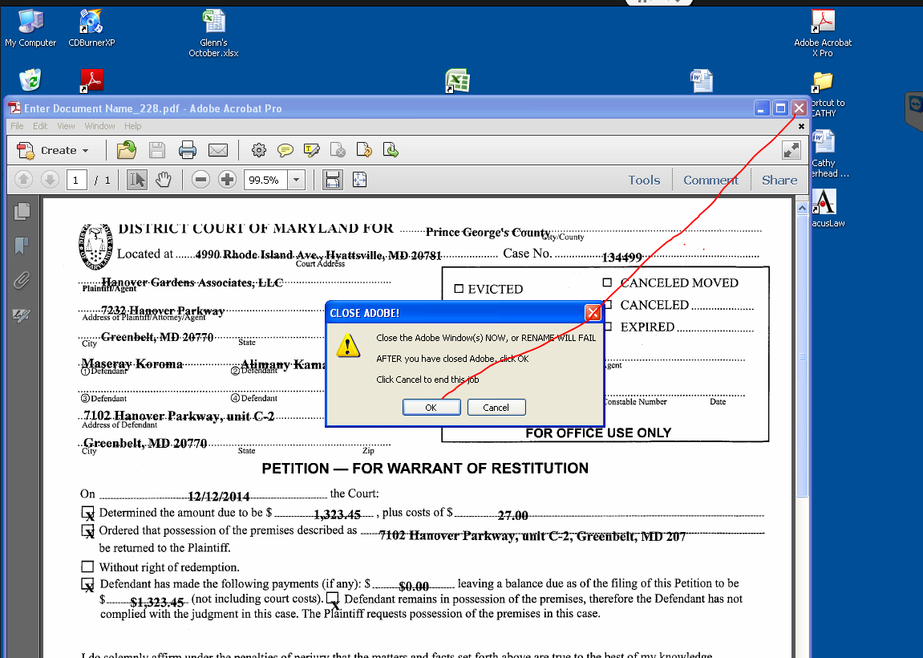

When you have finished renaming the files, you get the completion message.

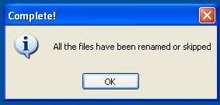

# EFile the Renamed Files

## Preparation

Start Internet Explorer, which may appear as iexplorer.exe on your Windows Start menu. Open the File Express Bookmark, and log in.

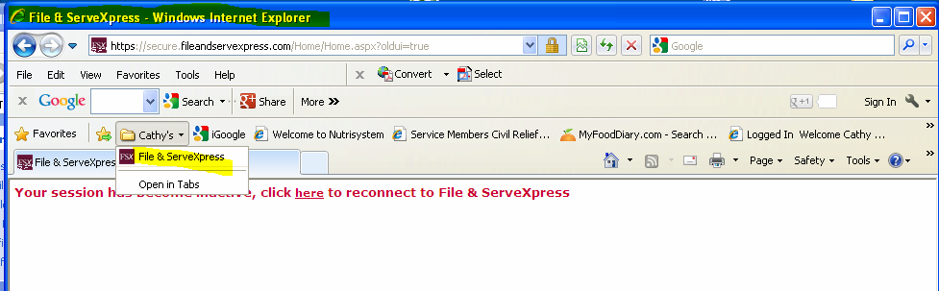

Click on Filing & Service, and on Start A Transaction.

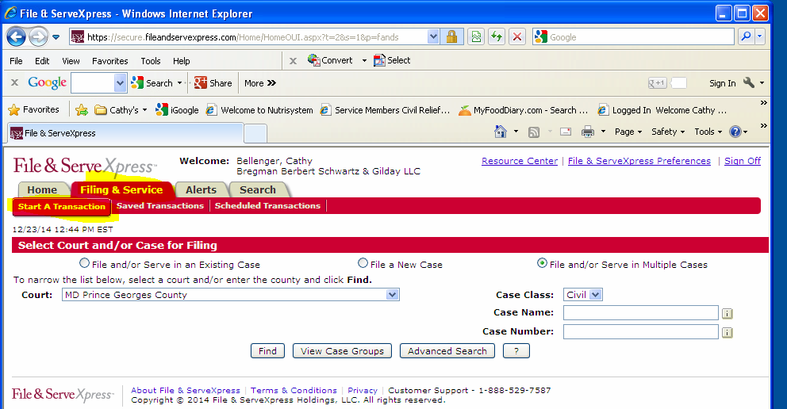

Leave that window open. You may want to move it to see the Desktop icon in the next step.

## Preparation is Finished, Efile the files

From the desktop, open the ShortCut to WinAutoQuick, and Right-click on Step W2 – Efile Named Warrants.exe, and Open.

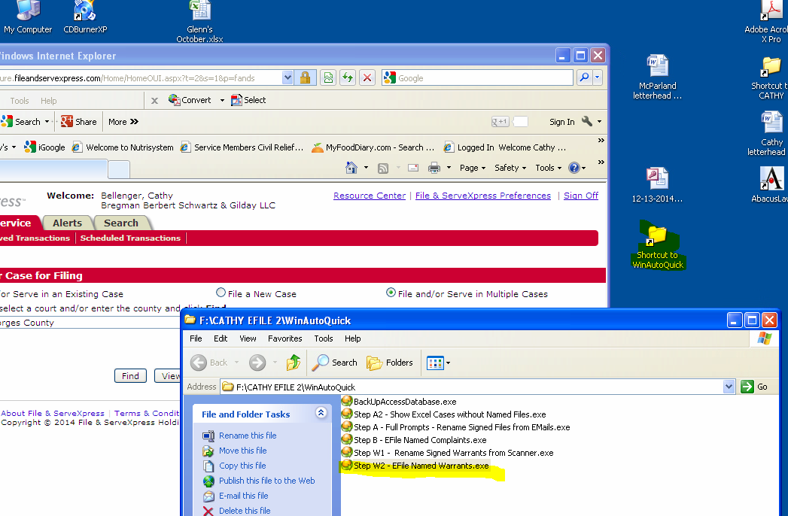

Minimize the WinAutoQuick Window, and click OK.

Enter your name, and accept the next two file locations.

When prompted, select the same xlsx file you made for Step W2. Do this by left-clicking it once. You will see the name repeated in the File Name: text box. Then, click Open.

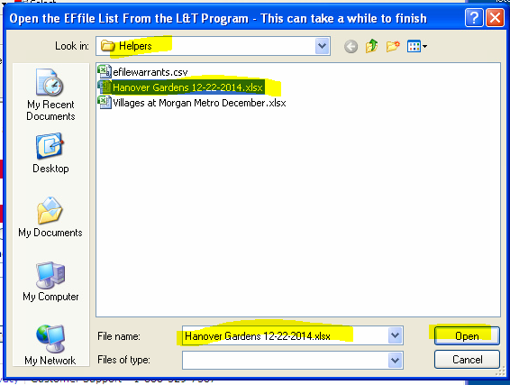

Edit the date and time for submission, and click OK.

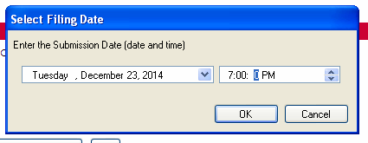

Enter the Plantiff, properly capitalized

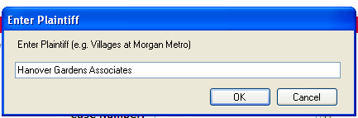

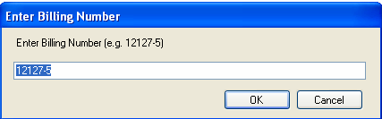x

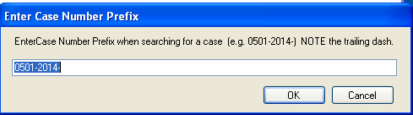C

Make sure everything is OK, then click OK.

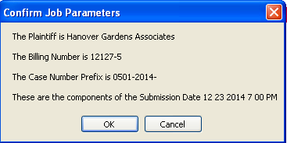

Once you click OK, the Web process starts.

The Excel window will be minimized automatically.

Drag the File Express window to the middle, so you can see it.

Wait a few seconds for the first document to be processed through early steps. You will see a window showing the document that is being processed After reviewing that the presented document agrees with the names displayed in the FileExpress window, close the window showing the (Adobe) PDF document by clicking the X at the top right.

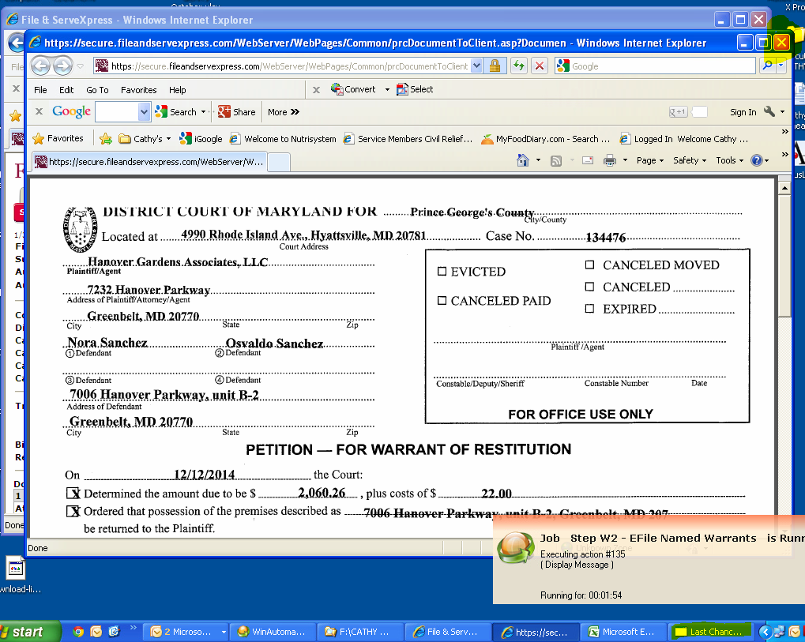

You may find that WinAutomation “Last Chance” message box prompt becomes blocked by the Receipt, or some other window. In this case, click ONCE on the highlighted icon on the tool bar in the screenshot above, to bring it forward.

Click on the “Last Chance” WinAutomation button.

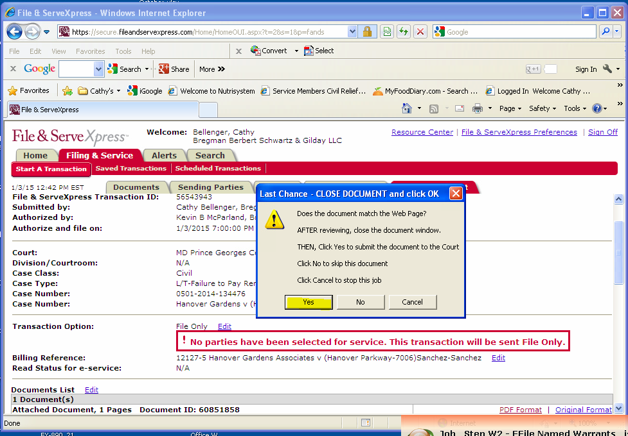

The receipt will be printed, and you will see a Message Box telling you to close the Receipt window, and the (Adobe) Document window (If you haven’t closed it already), and then click Yes to continue. The next case will start.

